Assembling a List of Monitored Marine Species in the Northeast Pacific to Inform DNA Reference Barcoding Efforts

What needs to be done
- Buttoning up of analyses
  - Manual curation
- Journal ideas
  - Molecular Ecology
  - Methods in Ecology and Evolution
- Sections
  - Figure 0. Workflow Diagram 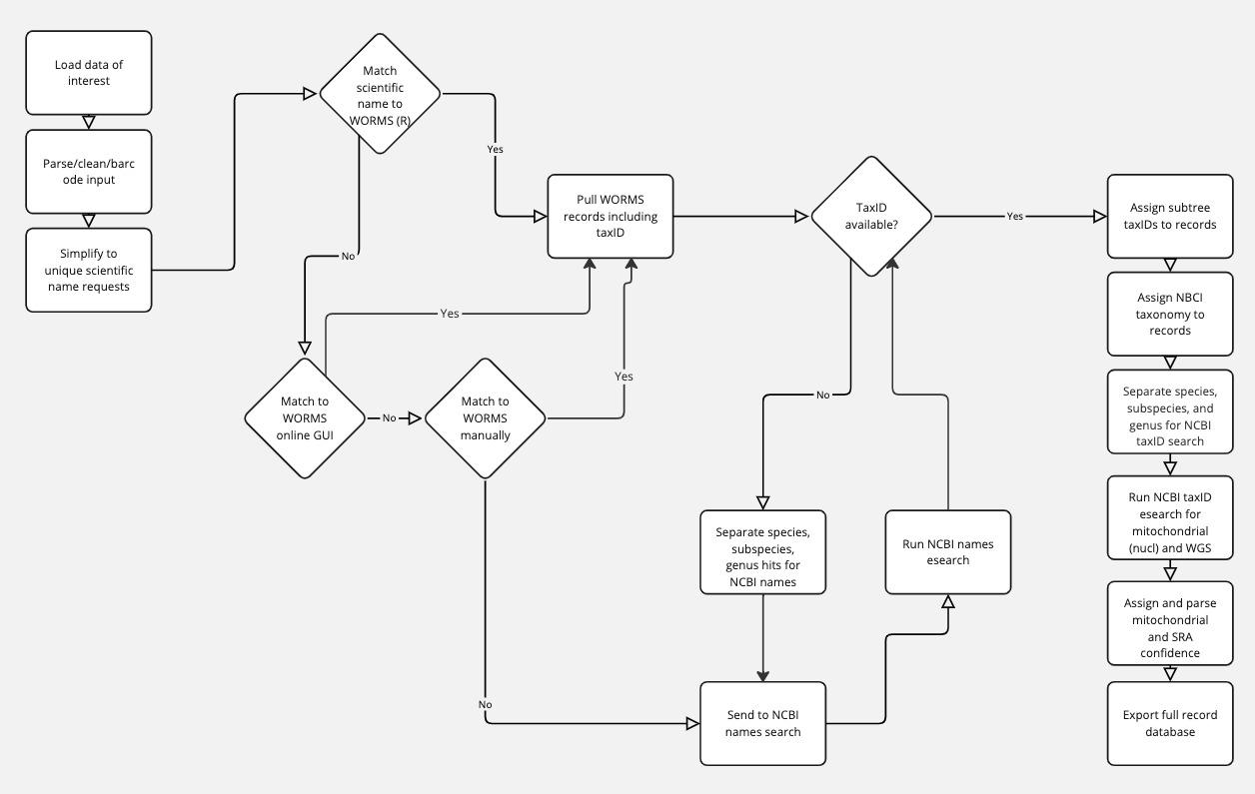
  - All of NEP
    - Figure 1. Query fate: Sankey Diagram
    - 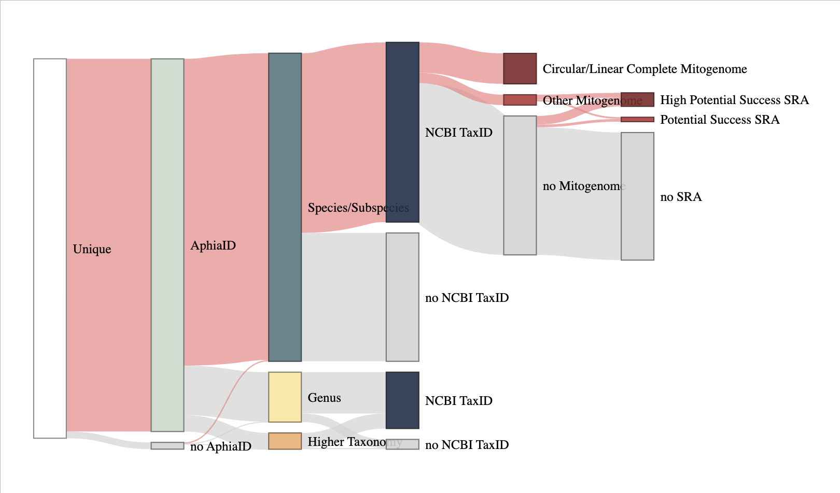
    - Figure 2abc. Marker coverage: rCRUX CO1/12S
    - Figure 2c. Mitogenome coverage/SRA
    - 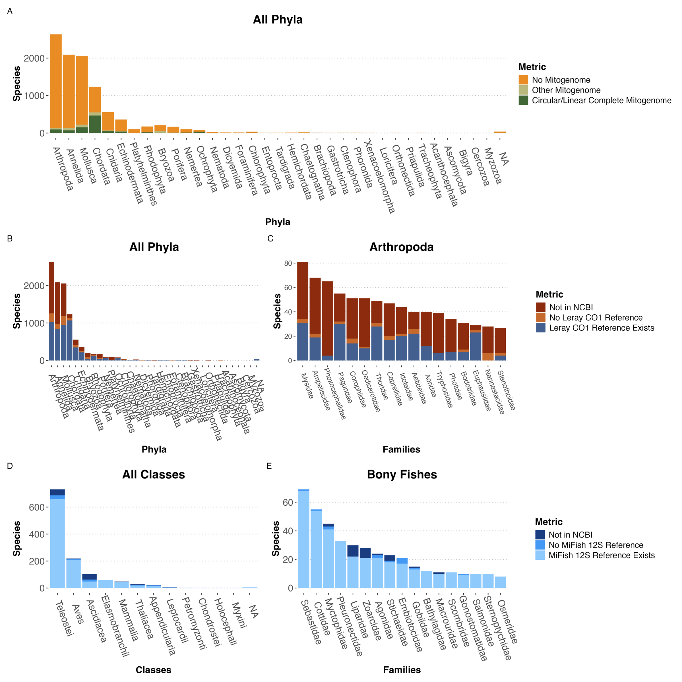
    - Supp Table By survey:
      - Number species in NCBI
      - Number species with Reference (CO1/MiFish)
      - Pull out information for text
    - Supplemental data file
  - Case study: Genus lookup
    - Unique list of genera from NEP req
    - Resolution and confidence scores for genera
    - Table/Figure 3. (box plot of % confidence split by taxa level of interest)
  - Case study: Changes over time
    - Inclusion of taxIDs in NCBI (drop off of accessions associated with taxID)
    - Figure 4. rCRUX accession metadata
      - Plot the presence/absence of records in current database
      - CO1 and MiFish
    - Figure 5. Mitogenome increase off over time
  - Case study: Fishes vs. rCRUX:
    - Figure 6. Resolution of fishes
    - Confirm plotting is real
    - Add in a rockfish specific example for the species resolution
    - Monitored (DAP) vs. encountered fishes from surveys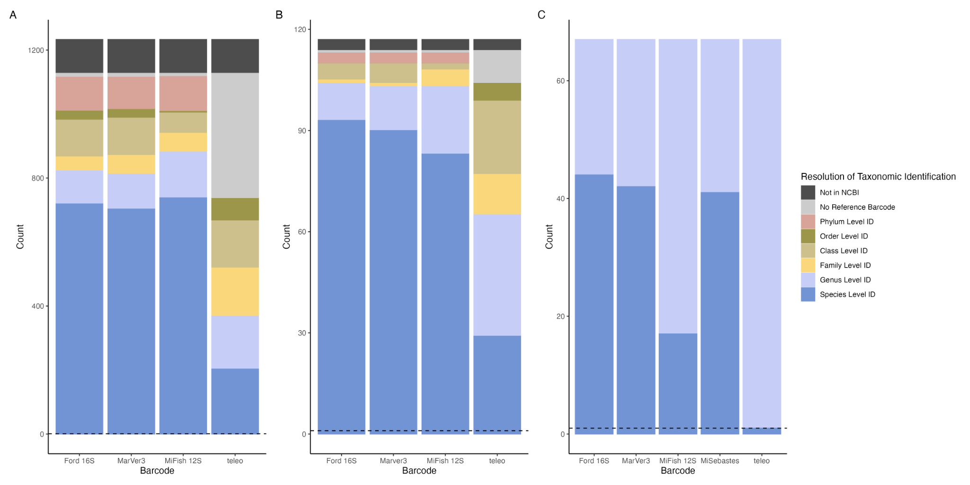
    - Figure 6. Comparison of resolution for Chordates for commonly used vertebrate markers for A) All NEP Chordates, B) Chordates Monitored by the Channel Islands National Park Service, and C) Rockfishes (Genus Sebastes).
  - Case study: Mitogenome example - Prioritization effort
    - Endangered Inverts (Haliotis-abalone; Pisaster)
      - Haliotis: Haliotis cracherodii; Haliotis sorenseni
      - Asteriidae: Pycnopodia helianthoides (proposed threatened species); Use this list: 20240322_sea_stars_ne_pacific
    - Does a mitogenome exist; target and prioritize sequencing efforts to fill gaps
    - Genus lookup for resolution question for coverage
    - Figure 7. COI marker resolution
    - Identify low hanging fruit in SRA that might be able to pull
      - Potential to do the mitogenome assembly of species with SRA records
  - Conclusion - highlight tool resource
    - Will need to create GitHub w/ readme

Abstract
Environmental DNA (eDNA) is a powerful tool for efficient, accurate and scalable marine biomonitoring. However, the development of accurate and valuable eDNA assays relies on comprehensive reference libraries of DNA sequences. Despite rapidly maturing eDNA technologies, there has been a lack of dedicated investment towards developing reference libraries for important marine taxa, severely limiting our ability to apply the technology for ecological health assessments. Here we conduct a gap analysis of available reference sequences for currently monitored species in the Northeast Pacific and Pacific Arctic ecosystems to provide an accounting of three decades of reference barcoding efforts and a priority list for targeted reference barcoding efforts in the region. We first assembled a list of XX species compiled from XX marine observation programs across the Northeast Pacific and Pacific Arctic spanning federal, state, academic, tribal, and NGO monitoring programs. Species lists were then synthesized and taxonomy was synonymized to both WORMS and NCBI nomenclature. We then cross referenced this species list against rCRUX generated reference databases for a suite of commonly used metabarcoding loci (Leray CO1, Kelly 16S, Machida 18S v8, 18S v4, 18s v9, MiFish 12S, and Baker dLoop) to identify both reference barcode availability and taxonomic resolution of each marker. We further cross referenced the NCBI mitochondrial genome database to quantify whole mitogenome availability. We demonstrate that the vast majority (xx%) of monitored [target group e.g. fish, mammal] have sufficient reference sequences while there is a severe paucity of reference sequences and mitochondrial genomes for invertebrate taxa (XX %). We further demonstrate that barcoding efforts have been unequal across the mitochondrial genome with the greatest coverage for XX loci. Importantly, we demonstrate the need for dedicated reference barcode sequencing efforts for these priority taxa with little improvement in coverage and taxonomic accuracy over time for key eDNA metabarcoding markers. Our work provides a road map for priority Northeast Pacific barcoding efforts to allow for accurate and effective ocean biomolecular observation.

Introduction
DNA sequencing has transformed marine science and resource management, enabling a range of capabilities from population genetics to environmental DNA. Fundamental to the success of DNA sequencing capabilities is the accurate taxonomic classification of DNA sequences which inherently rely on comprehensive, voucher-based reference barcode databases. This is especially true for eDNA approaches which require a reference sequence database to make accurate inference of the species present or absent in a given ecosystem. Without such data eDNA surveys can fail to detect target species of interest or often worse, incorrectly identify sequences to the closest matching species with a DNA sequence. The consequences of such misidentification are profound, especially for endangered or invasive species, which has frequently been cited as a reason eDNA approaches have not been readily adopted into routine biodiversity monitoring efforts. Thus there is a growing need for the development of such comprehensive and trusted genetic resources to underpin the efficacy and reliability of DNA sequencing capabilities and enable widespread adoption.
Previous work has demonstrated that despite three decades of barcoding of life efforts our publicly accessible reference databases (e.g. National Center for Biotechnology Information (NCBI), the Barcode of Life Data System (BOLD), the European Nucleotide Archive (ENA)) remain incomplete (Costa & Carvalho, 2007; Darwin Tree of Life Project Consortium, 2022; Hebert et al., 2003; Stoeckle & Hebert, 2008, Cummins et al., 2022; Ratnasingham & Hebert, 2007; Sayers et al., 2022). Gap analyses of reference database completeness have found wide-ranging results as a function of species group (e.g. fresh water fishes, marine invertebrates) and marker set (Weigand et al. 2019, McAllister et al. 2023). Unsurprisingly, charismatic megafauna and species of commercial and economic interest receive the lion's share of sequencing effort. However, because resources to support such foundational genetic infrastructure have been sporadic and inconsistent, even large, fished species lack any genetic data in publicly available reference databases (e.g. Metacarcinus anthonyi, Yellow Rock Crab ). In addition, as DNA technologies and applications change, so has the utilization of specific DNA marker sequences. CO1 remains the most commonly sequenced reference barcode gene for species identification because of its wide utility, conserved nature, and it being selected as the target gene for large scale barcoding of life initiatives (e.g. BIOCODE, Census of Marine Life), but there are hundreds of DNA sequencing capabilities including eDNA metabarcoding approaches that rely on a suite of other marker targets for which our repositories are severely lacking (e.g. MiFish 12S, Machida 18S, Gold et al. 2021, McAllister et al. 2023).
Systematic evaluation of the completeness of reference sequences have previously been focussed on specific targeted species lists for a target single gene. These tools and approaches are valuable, but are limited in utility as the complexity of DNA sequencing approaches necessitate the evaluation of a multitude of marker genes and target taxa completeness. This effort parallels the expansion of our reference sequencing efforts towards mitogenome skimming to recover a broader array of barcode genes and develop comprehensive coverage of key taxa of national interest (e.g. Smithsonian Institution National Museum of Natural History goal of generating mitogenomes for all North American fishes). Given these ongoing efforts and exponentially expanding public reference database growth, there is a need to conduct gap analyses and update reference databases on a routine basis.
Here we present a workflow for conducting routine gap analyses for any user-provided list of species of interest across both whole mitogenomes and any genetic loci of interest. We evaluate the completeness of reference databases for a list of species that are routinely monitored by ongoing U.S. based marine ecosystem assessment programs in the Northeast Pacific as defined as North of 30°N, including the Pacific Arctic.
The Northeast Pacific region as defined here encompasses a suite of regional and globally importance large marine ecosystems including the California Current, Gulf of Alaska, East Bering Sea, and Chukchi Sea. This region supports the majority of U.S. fisheries by both volume and landings estimated at XX and XX in 2024. Furthermore, the marine biodiversity of the Northeast Pacific plays a vital role in the cultures and traditional practices of coastal North American tribes and First Nations. This importance of the marine biodiversity of this region is further highlighted by the designation of 6 National Marine Sanctuaries, including the recently enacted Chumash Heritage National Marine Sanctuary as well as 124 MPAs in California, 14 MPAs in Oregon, 127 MPAs in Washington, and 13 MPAs in Alaska. Effective management of marine resources within the Northeast Pacific requires routine monitoring of its marine biodiversity to inventory and map the status and trends of distributions, abundance, and diversity. As DNA sequencing, especially DNA, is increasingly used for routine biomonitoring applications, there is a need to conduct gap analyses of existing genetic resources for species targeted by routine monitoring programs. Here we surveyed a diverse set of 26 marine monitoring programs across the Northeast Pacific to conduct a gap analysis within the region (Table 1). This gap analysis of existing publicly available DNA repositories provides an important target for reference barcoding efforts across the Northeast Pacific Region.

Methods

We developed a workflow for conducting gap analyses on any provided species list for mitogenomes and any marker of interest (Figure 1).

Taxonomic Quality Control
A series of quality control steps were developed to process submitted taxonomic data including removing extraneous white spaces, superfluous text (e.g. sp. And spp.), higher-level taxonomic groups (e.g. Phyla, Family, or Genus nomeclatures), and non-standard characters (e.g. #, -, _, parentheses). Cleaned taxonomic strings were then used to acquire AphiaIDs using the wm_name2id() script from the worrms R package. Species that failed to return AphiaIDs were manually run through the WORMS Match Taxa portal which enables ambiguous searching unlike the automated function. Species that still failed to obtain AphiaIDs were then processed using the taxonimzr getTaxonomy() function. Finally, for the remaining species that could not be programmatically processed, we manually curated provided taxonomic nomenclature. These almost exclusively represented typographical or copy/paste errors or recently suggested species classifications that could be resolved from a simple internet search. Here we manually curated all taxonomic nomenclature and excluded recent species divergences that did not yet have Aphia IDs. For all species with Aphia IDs, the wm_external_() function was then used to acquire NCBI IDs to enable cross-referencing of species lists with NCBI GenBank and existing rCRUX reference databases.

Gap Analysis
In order to conduct a gap analysis we first queried NCBI Sequence Read Archive for whole genome sequences and GenBank for nucleotide sequences using the NCBI e-utilies. Metadata for mitochondrial genomes (e.g. XX, YY, ZZ) was parsed to identify the occurrence of whole genome sequences as well as mitogenomes (complete circular, complete linear, verified/unverified, and other genome). These results were then parsed into a table recording informative results.
To query specific marker genes, we relied on rCRUX which is a simple-to-use tool for the generation of curated, comprehensive reference databases for user-defined loci. Previous work has demonstrated that rCRUX provides highly accurate and comprehensive marker specific reference databases. Here we query the NCBI taxonomies from the user provided species list against a specific rCRUX reference database. To date there are 24 rCRUX reference databases for a suite of commonly used metabarcoding targets.

Northeast Pacific Case Study
We surveyed federal, state, regional, academic, and community science-based marine monitoring programs in the Northeast Pacific between January 1, 2024 and July 4th, 2024, receiving detailed responses from 26 marine monitoring programs within the region. Responses were then organized and collated into a single database (Table S2).

We evaluate the completeness of existing publicly available reference sequence databases for mitochondrial genome and 6 metabarcoding genes of interest: Leray Metazoan CO1 (Leray et al. 2013), Machida Metazoan 18S (Machida et al. 2012), Kelly Metazoan 16S (Kelly et al. 2017), Amaral-Zettler Phytoplankton 18S v9 (Amaral-Zettler et al. 2009), MiFish Teleost 12S (Miya et al. 2015), and Ford vertebrate 16S (Ford et al. 2016). In addition, we track the rate of species deposition into reference databases over time.

Results

Across all 26 marine monitoring surveys for whom we received responses, we obtained a list of 9,761 unique species covering 4 Kingdoms, 34 Phyla, 82 Classes, 330 Orders, 1554 Families, 4,248 Genera, and 9,761 species in the Northeast Pacific.

We found that 44.4% of all species monitored in the Northeast Pacific had no record in NCBI indicating it has never been sequenced (Table 2). This distribution of sequences in NCBI was not even across Phyla (0-100%, average = XX) with all monitored Hemichordates lacking sequences and all Phoronida species having sequences (Figure 2). The results demonstrate the paucity of reference sequences for Northeast Pacific species, particularly marine invertebrates.

Metric | Count | Percent
WORMS & NCBI Tax Matched | 5,127 | 52.2 %
Different Taxonomic Name | 341 | 3.5 %
Not in NCBI | 4,362 | 44.4 %

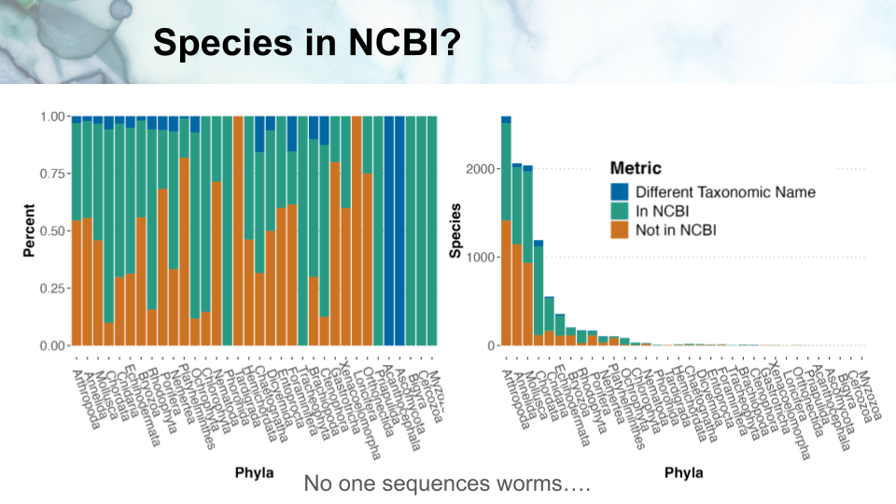

Only 16% of all species had any mitochondrial genome in GenBank, highlighting the paucity of comprehensive genetic resources needed for DNA sequencing capabilities (Table 3). Mitogenome coverage was similarly biased by phyla (Figure SXX).
Metric | Count (verified/unverified) | Percent
Any Mitogenome | 1213 | 12.4% of species // 22.4% of species w/ NCBI records
High confidence mitogenome (complete circular/linear) | 889 | 9.1% of species // 16.4% of species w/ NCBI records
Complete Circular Mitogenome | 876/6 | 72.7% of mitogenomes
Complete linear mitogenomes | 16/0 | 1.3% of mitogenomes
Incomplete Circular mitogenomes | 93/2 | 7.8% of mitogenomes
NCBI submission issue (claim complete but not coded that way) | 54 | 4.5% of mitogenomes
Partial mitogenomes | 464 | 38.3% of mitogenomes
Partial mitogenomes only | 294 | 24.2% of mitogenomes

Across the 6 metabarcoding loci we found a wide range of species coverage (Table 4) with Leray Metazoan CO1 having the highest and Amaral-Zettler Phytoplankton 18S having the fewest. We similarly find wide biases in completeness across taxonomic groups with marine mammals and elasmobranchs consistently having the smallest reference database gap (Figures 3-4, SXX-XX).

Lastly, we demonstrate that the rate of increase in additional DNA reference barcodes has not been linear nor consistent across marker sets (Figure 5). CO1 has the greatest number of reference sequences while XX has the least.

Discussion

- Many species missing data
  - Uneven sequencing across species, markers, and habitats
  - Charismatic megafauna get all the love
  - Many taxa of interest are missing crucial genetic resources
    - Highlight commercial examples
    - Protected species examples
    - Invasive species examples
- Importance of voucher sequencing
- Need for supporting taxonomists and natural history
- Importance of mitogenome skimming
  - Future proof reference databases
  - qPCR assay development
- Value of the gap analysis workflow/tool
- This tool can incorporate any input reference database, including curated reference databases like MetaZooGene.
- Can be repeated for any case study of interest
- rCRUX databases being updated routinely
- Need for dedicated sequencing effort moonshot to fill these gaps
  - Key for critical strategies
    - National Aquatic eDNA Strategy
    - National Ocean Biodiversity Strategy
  - Highlight dedicated efforts success and future upcoming efforts
  - Support local, indigenous, regional, state, and national marine monitoring efforts

References

